Bridlington School SMSC Curriculum

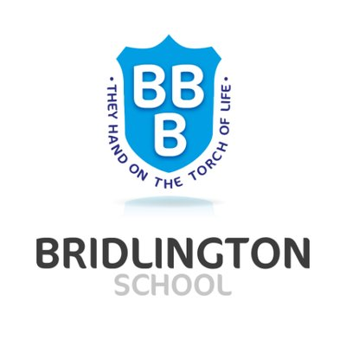

Criminology SMSC Provision

Spiritual development

Through the curriculum, pupils develop:
- An ability to be reflective about their own beliefs, religious or otherwise, that inform their perspective on life and their interest in and respect for different people’s faiths, feelings and values
- A sense of enjoyment and fascination in learning about themselves, others and the world around them
- A use of imagination and creativity in learning
- Willingness to reflect on their experiences

In Criminology we consider how different values and beliefs can affect criminality and how the public and the media responds to these crimes committed. Throughout the course they have multiple opportunities to debate and discuss their own thoughts and beliefs through various topics.

Moral development

Through the curriculum, pupils develop:
- An ability to recognise the difference between right and wrong and readily apply this understanding in their own lives, recognise legal boundaries and, in so doing, respect the civil and criminal law of England
- An understanding of the consequences of their behaviour and actions
- An interest in investigating and offering reasoned views about moral and ethical issues and ability to understand and appreciate the viewpoints of others on these issues

In criminology learners are taught the basics of how to establish criminal liability and the process from the crime to the court room. We also consider how crime and deviance changes over time to reflect society’s morals and norms.

Social development

Through the curriculum, pupils develop:
- A use of a range of social skills in different contexts, for example working and socialising with other pupils, including those from different religious, ethnic and socio-economic backgrounds
- A willingness to participate in a variety of communities and social settings, including by volunteering, co-operating well with others and being able to resolve conflicts effectively
- An acceptance and engagement with the fundamental British values of democracy, the rule of law, individual liberty and mutual respect and tolerance of those with different faiths and beliefs; they develop and demonstrate skills and attitudes that will allow them to participate fully in and contribute positively to life in modern Britain

Criminology offers lots of opportunities for group discussions and we teach them in this subject to respect what others are saying and provide evidenced arguments. Students are also able to work in pairs or small groups to discuss different concepts and present ideas to the rest of the class. We also look at how society and its beliefs have changed over time to affect what is considered a crime or not.

Cultural development

Through the curriculum, pupils develop:
- An understanding and appreciation of the wide range of cultural influences that have shaped their own heritage and those of others
- An understanding and appreciation of the range of different cultures within school and further afield as an essential element of their preparation for life in modern Britain
- A knowledge of Britain’s democratic parliamentary system and its central role in shaping our history and values, and in continuing to develop Britain
- A willingness to participate in and respond positively to artistic, musical, sporting and cultural opportunities
- An interest in exploring, improving understanding of and showing respect for different faiths and cultural diversity and the extent to which they understand, accept, respect and celebrate diversity, as shown by their tolerance and attitudes towards different religious, ethnic and socioeconomic groups in the local, national and global communities
There is a large element of culture in Criminology and how society has changed throughout the years determining not only how psychologists view crime and deviance, but also how society as a whole has changed its view on what should be illegal or not.

